Sycamore Avenue / Knottingley/ WF11 0PJ
T: 01977 722515
E: info@simpsonslane.org.uk / W: www.simpsonslane.org.uk
Head of Academy: Mr L Colley
Vice Principal: Mrs S Ellis

Newsletter 05/12/25
Children who demonstrate an acceptable standard of behaviour are awarded points. To be awarded a point the children would have to be in the right place, at the right time and doing the right thing.
This week 386 children have been GREEN all week.
WELL DONE!




Dear Parents and Carers,
It has been another wonderful week in the academy and the children have been busy practising for their Christmas Concerts in Key Stage 1 and 2. The children in Year 6 have also been participating in Bikeability, which helps build their confidence in riding a bike as well as teaching them the importance of road safety when cycling. This will be continuing next week as well so if you see them riding on the estate please give them some positive encouragement! We have also added Elf Day to our calendar where we will be raising money for Alzheimer’s awareness.

Upcoming Dates

17/12 – Bedtime Stories (EFYS and KS1)
17/12 – Year 5 and 6 Christmas Concert and Crafts @2pm
17/12 – Christmas Dinner Day
17/12 – Christmas Jumper Day
19/12 – Break Up
05/01 – Return to School
09/01 - Inset Day
09/12 – Reception Christmas Stay and Create @8.30am
09/12 – Nursery Christmas Stay and Create @8.30am and 12.15pm
10/12 – 2LR Stay and Read
10/12 - Christmas Fayre
11/12 – 4NR Stay and Read
11/12 – Year 1 and 2 Christmas Songs and Crafting @2pm
12/12 - Pantomime
15/12 – Elf Day
16/12 – Year 3 and 4 Christmas Concert and Crafts @2pm

3ED- Izabella for trying hard to perfect her handwriting.

3SF- Louie for being amazing and being back in school full time

4EC- Omar for having a fantastic week in all subjects and an amazing attitude to learning

4NR- Ife or always blowing me away with his knowledge inside the classroom and out! His Hot Write was incredible and really impressed his peers when he read it allowed with so much expression!

5KR- Charlie for always working hard and setting a good example to the rest of the class

5CT- Isaac - he has been on the ball all week and concentrating really well on his tasks within every lesson. Well done, I'd love to see this again!

6SW- Elliott for his effort in arithmetic sessions and his increased speed

6SC- Hunter for trying really hard in all lessons

NURSERY AM- Bethany. S! For being an amazing friend and always thinking of the kind thing to do!

NURSERY PM - Natalia. T! For trying so hard with her phonics and really concentrating on the sounds in the words!

RRS- Cooper for HUGE improvement in his handwriting. What a superstar!

REH- Reggie H-S for having a fantastic attitude towards his learning this week

1KR- Roseann for trying hard with her phonics sounds and reading words

1JS- Kobyn for giving 100% effort and making some great progress in phonics

2KW- Maya for always trying her best

2LR- Nashe C for impressing me and constantly trying to progress in his reading

Stars of the week

.
Nursery
This week in Nursery we have started our new Talk for Writing story, 'Dear Santa'. The children were very excited to see what was in the presents that Santa left in the classroom. One by one we opened them up and discussed if we thought it would be a good present for us. The children had some great ideas. The trumpet was definitely the first to leave the classroom... too noisy! But we sent it back to Santa so that he could give it to a different boy or girl instead.

In Phonics this week we have been completing rhyming pairs and listening carefully to the words to see if they rhyme or not because Miss Gardom made it super tricky for the children to make their rhyming rainbows work. In maths we have extending our learning with pattern creating an ABC pattern with 3 different items repeating. We have been able to talk in detail about the rules for patterns to make this very easy to complete.

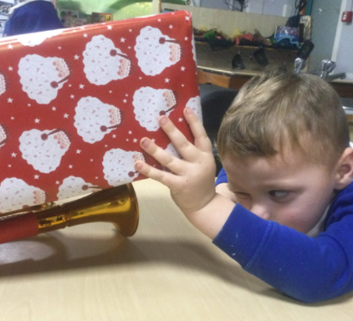
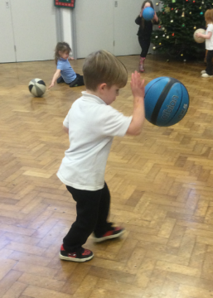
Reception

What a fabulous week we have had in Reception! The children have been exploring our story 'Stick Man' by exploring the sticks in our outdoor area, modelling stick man in the playdough and even making their own Stick Men! In PE we practised ball skills and practised dribbling the ball in different weathers.
In maths we have been exploring the composition of the number five. Well done Reception!

Our phonics sounds of the week are reviewing:
j v w x
Our word of the week is: Pooh Stick

1KR

This week has been an incredibly exciting week for year 1 as we had a special visit from a cheeky little elf on Monday. We are going to be writing a recount of his adventures for the next 3 weeks.
In Maths we have been looking at doubles and how to double numbers both practically and through problem solving's.
In science on Tuesday, we enjoyed looking at properties of materials and carried out an experiment to find out the difference between waterproof and absorbent.

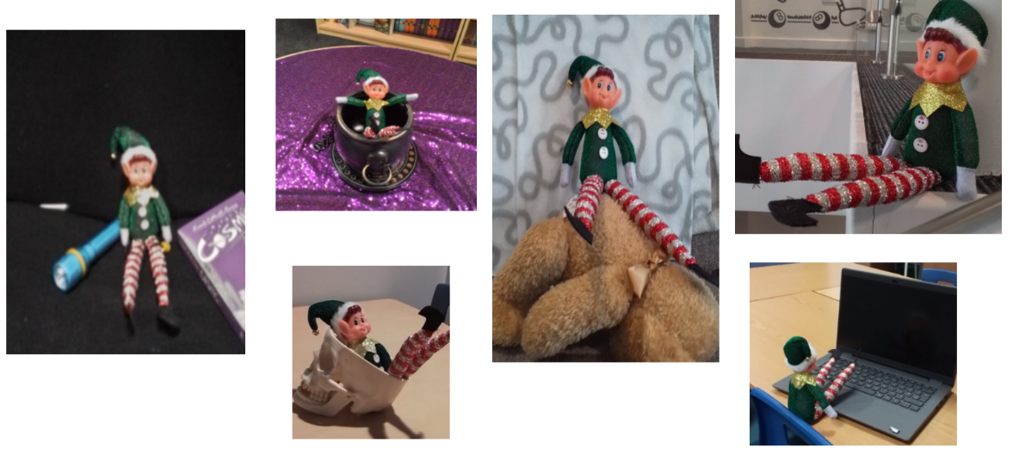

1JS
The 1st December brought with it the Elf on the Shelf. We even had a visit from a real life elf! We have started our unit of writing which is a recount so we are learning how to write in the first person as well as ensuring our writing has a beginning, middle and end. This is linked to the Elf on the Shelf.
Our maths focus is learning doubles of numbers to double 10. We are using this knowledge to then find near doubles by recognising the double first (eg 5+6 can be calculated by knowing double 5 and one more).
In science, we have learnt some properties of materials and we did an experiment using different materials to see if they were waterproof or absorbent.
We have been practising our songs for our concert next week and we are looking forward to performing them for you.

2LR
In PE, we have been using the aparatus to show off balances and perform sequences. In DT, we have designed and constructed houses using nets to make cubes. We will create Pudding Lane later in the half term and re-enact the Great Fire of London. In Maths, we have used arrays to help us build on our multiplication skills. In Writing, we have been debating who is to blame for the fire and we will write our own debate on whether we should or shouldn't wear school uniform.

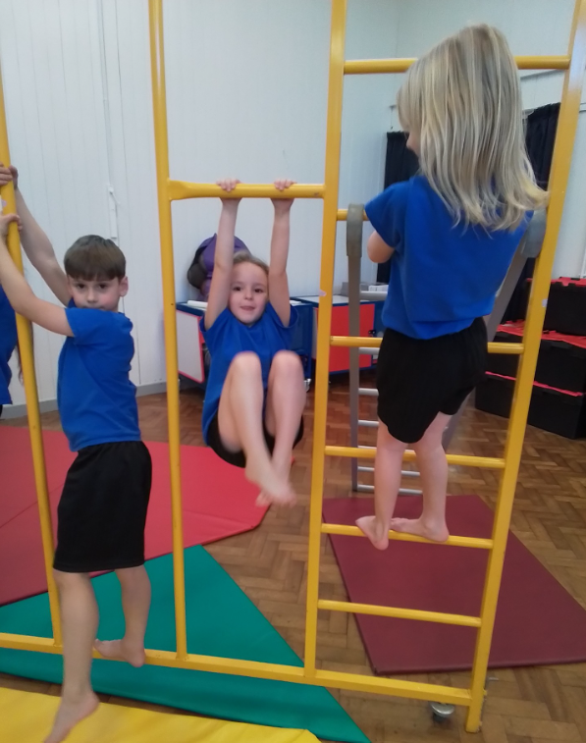

2KW
This week Year 2 have had lots of fun trying out the gymnastics equipment in the hall and were all very sensible whilst doing this. They have used what they have been learning in the previous weeks to practice their balances and travelling movements. In Maths the children have begun learning about the multiplication symbol and have been using their times table knowledge to solve multiplication sentences. As well as this the children have made bruschetta in Classroom kitchen. Lots of children tasted some of the ingredients and earnt lots of green points for trying something new.
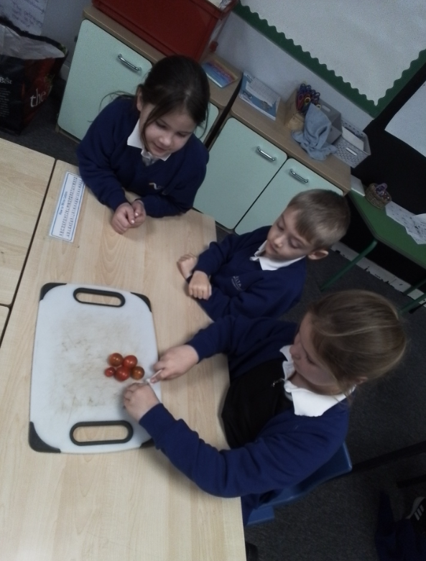

3SF
This week in Reading, we finished our class book This Morning I Met a Whale. The children absolutely loved this story and were genuinely sad to reach the end. We have also been exploring a newspaper article about a whale spotted in the River Thames. The class has been fascinated to learn about the real-life event that inspired our book!
In Maths, we have started our new unit on fractions, and Year 3 have been amazing already. They have really grasped the key concepts and shown great enthusiasm during lessons.
In Writing, we have now completed our text map for How to Tame a Dragon, and the children are excited to move forward with their ideas. They all have some great ideas for actions to use when reading our text map!
We have also been practicing for our Christmas concert this week, Year 3 are great performers, we can’t wait for the Christmas concert
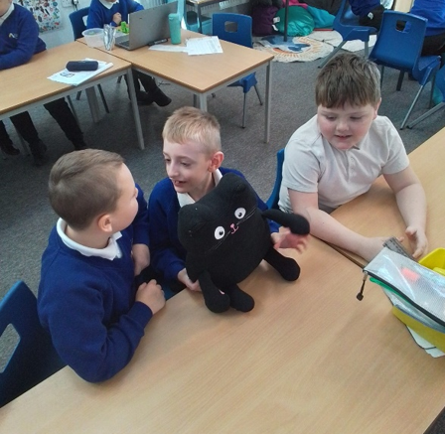

3ED
In maths, we have started exploring fractions, building our understanding step by step.
In writing, we finally finished “This Morning I Met a Whale.” We’ve had fun researching what inspired Michael Morpurgo to write the book.
In history, we investigated fascinating Iron Age discoveries, learning about how people lived long ago and the tools they used.
In French, we have been practising how to say and spell numbers.
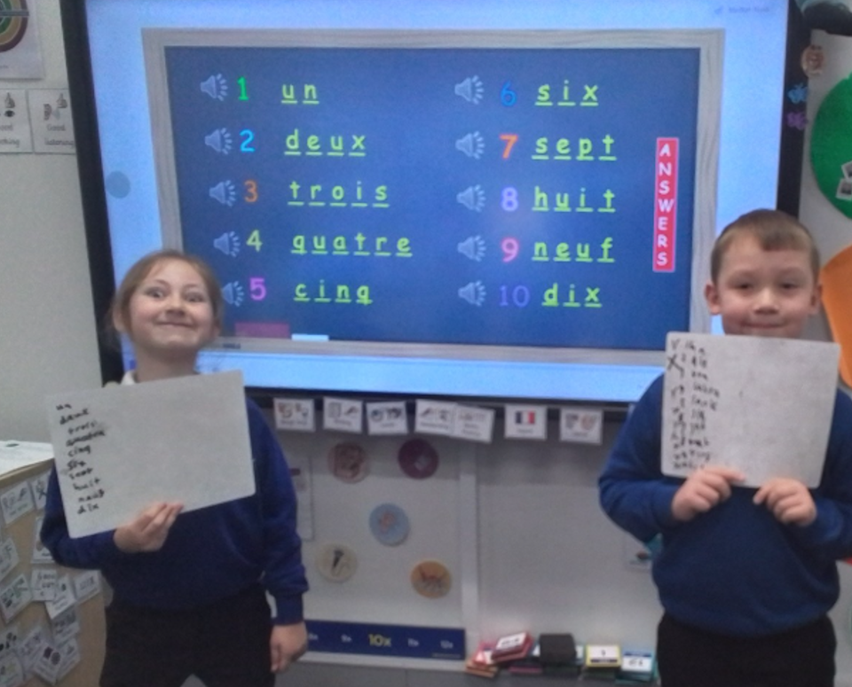

4NR
Another busy week for 4NR, we finished our R.E unit on right and wrong the children created their own T.V shows and I was amazed with how much they could remember from this half term! In reading, we looked at Pinocchio this week and the children enjoyed learning all about how he was created. In writing we started a new unit on food reviews the children really enjoyed telling me all about their favourite meals. But the children's highlight has to be taking part in 'I’m a Year 4 Get Me Out Of Here!!' Have a fab weekend 4NR.

# 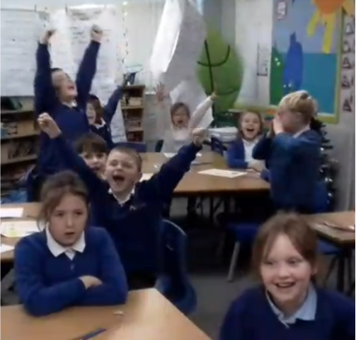

4EC
A wonderful week five for us in 4EC! We started off the week wrapped up warm, ready for our forest school lesson. The children worked in groups of four and played some bug bingo! Our competitive sides took over and it was so much fun! In reading this week, we have been looking at the story of Pinocchio. We have looked into Master Cherry's character and predicted what we think may happen next... In writing, we have focussed on creating food reviews! We have thought about our favourite meals and what makes them delicious! We have had fun looking at different savoury and sweet foods to get our creative minds whirring. In RE, we have reflected on the three religions we have covered this half-term; Christianity, Judaism and Buddhism. We worked in teams to put our facts together to make TV shows! They were brilliant, we definitely have some aspiring actors in year four. In Geography, we put our minds together to think about what makes a good community, we thought about where we live and what makes it a good location. Then we looked at the most and least populated areas in North America. Have a lovely weekend everyone!

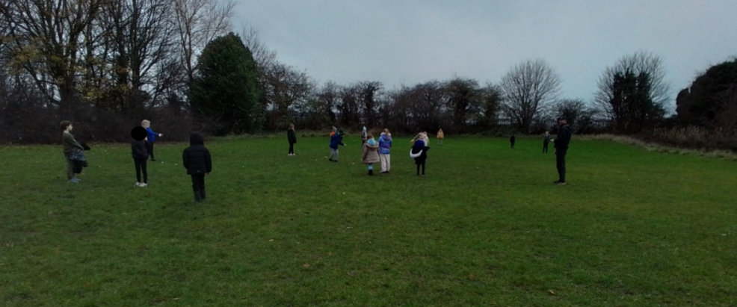

5KR
This week, in reading we have been practising our reading test skills in preparation for our end of term exams. We have been working so hard to read texts quickly and find evidence. In Maths, we have continued our fractions unit and completed an arithmetic test to test our learning so far! We have done so well. In Writing, we have began to look our new text of an Information text. We have looked at our model text, which is about the beast Grendel.

In Geography, this week, we have looked at another natural disaster of volcanoes. We have labelled a volcano and looked at adjectives that can be used to describe a volcano. In Science, we finished off our topic and looked at how humans develop through puberty. In Computing, we have had the opportunity to go on laptops again and look at web pages.
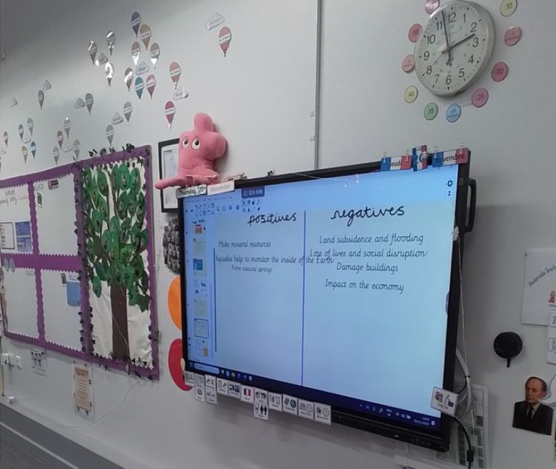

5CT

In maths we have been looking at converting between fractions and using our times tables knowledge to help with this. In Reading, we have been exploring more of Elliot's story and focusing more on what dialogue shows the reader, how a character feels and whether characters get along with one another or not. The children have enjoyed looking at script versions of the dialogue and play-acting these out using their knowledge. In writing, we have been looking at poetry and making our own based on the monster 'Grendal' and then we have been looking at our information model text and trying to remember the model text by using different actions.

In the afternoons, the children have done well with adding to their geographical knowledge of natural disasters - we looked at volcanoes and the features of a volcano as well as researching different volcanoes in the world and looking at whether they are dormant or not. In computing, we have been looking at what a search term is and how important it is that it shows us the correct things - we need to be specific.

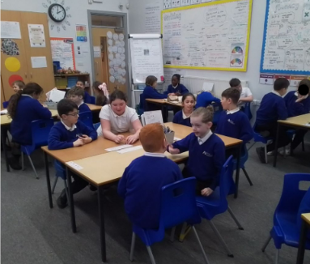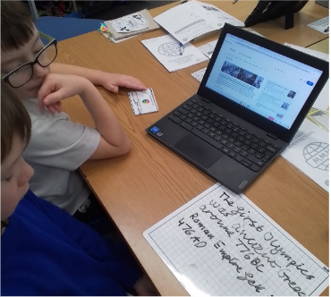

6SC
This week we continued exploring human impact on Antarctica. The children investigated how tourism, scientific research, and climate change affect this fragile environment. We discussed the importance of protecting the continent and considered how humans can reduce their footprint in such a unique ecosystem. In Computing, the class planned a party using spreadsheets. They learned how to use formulas for addition, multiplication, and calculating averages, and they practised working within a budget. Pupils enjoyed seeing how spreadsheets help organise information and make decisions efficiently. Our Maths focus was on calculating the mean and applying BIDMAS (Brackets, Indices, Division/Multiplication, Addition/Subtraction). The children practised step-by-step reasoning and solved increasingly challenging problems using the correct operation order. In Writing, the children became explorers and began imagining what it would be like to journey to Pandora—a mysterious and vibrant world inspired by science fiction. They brainstormed descriptive vocabulary, sensory details, and ideas to bring this imaginative setting to life in their upcoming writing. Next week, our class will be doing Bikeability so those children who are using their own bikes and helmets will need to remember them on Monday. Thank you for your continued support.
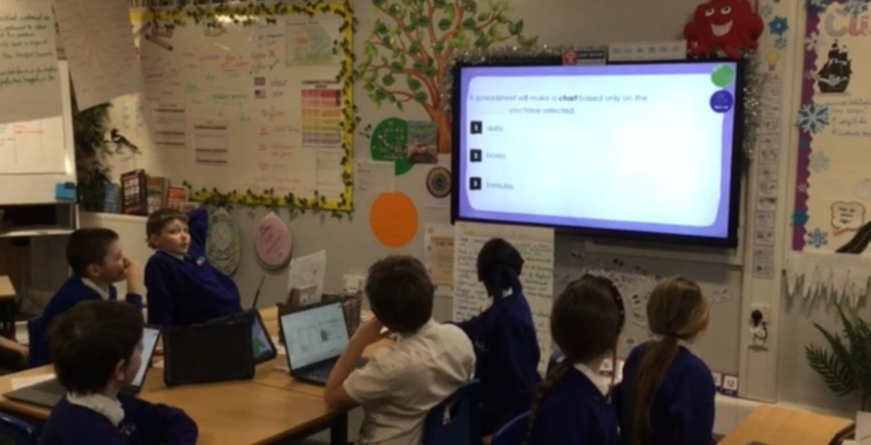

6SW
In Bikeability, we learned all about staying safe on the roads, practising our cycling skills and building confidence when riding in real-life situations. We thoroughly enjoyed ourselves, and our instructors even said we were fantastic — a wonderful reflection of the children’s sensible behaviour and brilliant attitude. Throughout the week, we also spent time working on targeted interventions in Reading, Maths and SPaG, focusing on the areas where we each needed a little extra support. The small-group activities were enjoyable, and everyone showed great focus and determination to close their gaps. In PE, we continued our gymnastics unit, progressing further by combining a greater range of movements into our routines. Our control, balance and creativity are improving every week. In French, we took our learning a step further by forming extended sentences about our pets, using conjunctions to add more detail and fluency to our spoken and written French.
We have also been really pushing SATs Companion this week, as it is an amazing resource to support learning at home and in school. Ask your child to show you how it works — it’s a brilliant tool for revision and practice!

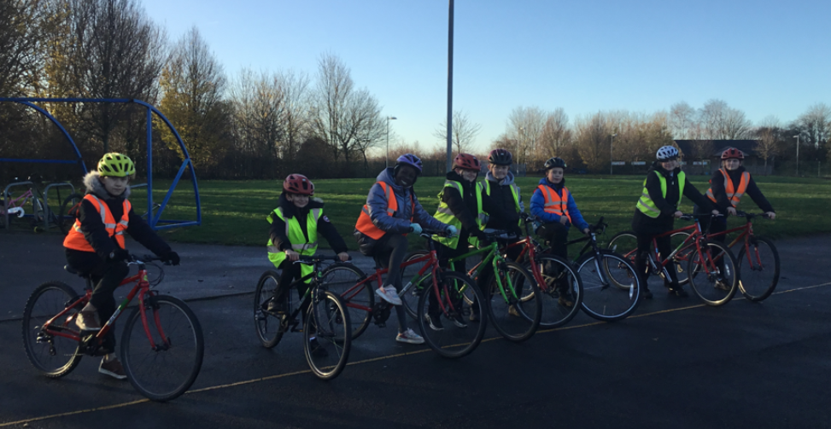

Simpson’s Lane Academy Safeguarding Team

If you have any concerns about a child or member of staff, please contact one of our safeguarding team. Our safeguarding leads are –

Mr Colley (Head of Academy DSL)

Mrs Silburn (Well-being Lead and Deputy DSL)

Mrs Ellis (Vice Principal and Deputy DSL)

Miss Coopey (Assistant Principal and Deputy DSL)

Miss Simpson (Attendance Officer and Deputy DSL)

